MHIPIP COORDINATORS fact sheet:
mental Pathways in practice Evaluation
You are invited to participate in the state-wide training and evaluation of the new Mental Health Pathways in Practice (MHPiP) Program. This evaluation is being undertaken in partnership with an independent evaluation service, the NOUS Group.
Before you decide to participate, it’s important for you to understand why the evaluation is being done and what it will involve.
What is MHPiP?
MHPiP is a new professional development pathway for clinicians working in Mental Health. It provides work-based learning opportunities to integrate learning into practice. MHPiP aims to increase consumer wellbeing outcomes by improving mental health clinical practice.
Each learning pathway has been developed in collaboration with nurses, allied health, medical, persons with lived experience and carer representatives to support mental health clinicians to deliver quality, contemporary and genuine care across NSW Health services.
Your role as an MHPiP Coordinator?
As the MHPiP Coordinator for your LHD/SHN, you are the go-to person for more information on MHPiP. You are being asked to support participants in their enrolment into the Pathways and participation in the state-wide evaluation. Equally as a participant you can enrol in the Pathways and evaluation.
Where can I access the MHPiP FAQs?
More information and FAQs on the MHPiP Program can be found: https://www.health.nsw.gov.au/nursing/practice/Pages/mhpip-coordinators.aspx
Who can access MHPiP?
MHPiP focuses on clinicians working in mental health, including nursing and allied health. Resources are also available for all NSW Health staff to increase mental health literacy.
How can I access MHPiP?
NSW Health staff can access MHPiP via My Health Learning.
What is the MHPiP learning approach?
The Programs four blended learning pathways aim to uplift confidence and capability and behaviour and cultural changes across the health system. The approach is inclusive of online resources and work-based/work-integrated activities to support development and/or enhancement of capabilities in practice. This method supports translation of knowledge into practice through experience of solving real-life problems within the context of procedures, protocols and organisational structures.
Are there benefits to mental health consumers?
Yes. Nurses and allied health staff will develop skills and ability to apply contemporary models of care, through adopting a recovery and trauma informed well-being approach (vs illness management).

What is the evaluation approach?
The evaluation approach is based on the Kirkpatrick Phillips Model (levels one to three) and a Realist Evaluation Approach. The evaluation is designed to improve our understanding of how and why MHPiP works or does not work in different settings. It will explore what changed for the evaluation participants. Plus, how capable and confident nurses and allied health staff are in delivering better care to mental health consumers. The evaluation feedback will enable HETI and NaMO to adapt this new contemporary program.
Four key lines of enquiry (KLEs) will guide and provide structure to the evaluation activities. The diagram below represents a summary of the model and the evaluation approach.

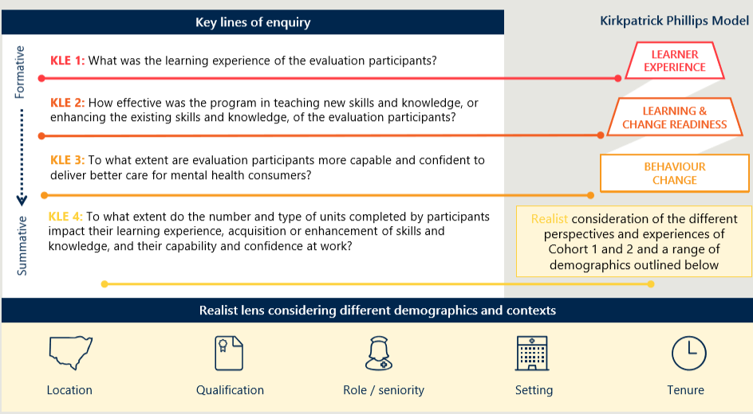
How was the evaluation approved?
The Human Research Ethics application was approved of through Hunter New England LHD, and there are Site Specific Application approvals (SSAs) for each LHD/SHN.
What are you being asked to do?
You are being asked to enrol in the whole MHPiP Pathway or individual MHPiP learning units and to agree to participate in the state-wide evaluation.
What information do participants receive?
Participants will receive a fact sheet that provides information on how to contact their LHD MHPiP Coordinator, and how to participate in the MHPiP program and state-wide evaluation. You may find this fact sheet useful to help facilitate conversations with participants.
Do you have to participate?
You do not have to participate in this evaluation. Whether or not you decide to respond to the evaluation participate, your decision will not affect your participating in the MHPiP program. If you choose not to participate in the evaluation, simply close the survey window on My Health Learning.

How do I participate?
You can search for MHPiP through the catalogue on My Health Learning and enrol in the full Pathway or choose individual learning units and add them to your own Online learning.

What are the Evaluation activities?
MHPiP evaluation activities will include surveys, focus groups, case study interviews and analysis of My Health Learning data
How to enrol in the Pathways and Evaluation?
There are two options available to enrol in the MHPiP program and evaluation, and you only need to complete option one or option two. As an MHPiP Coordinator we encourage you to take the time to become familiar with options one and two and the processes outlined below.

Option one: enrol in the whole MHPiP Pathway start by telling us about yourself through filling out the Pathway pre-training survey. Complete the 10 Pathway learning units at your own pace. When you have finished the learning units, complete the post- evaluation survey. The pre-training survey and post-training survey will each take 30 minutes to complete and cover questions related to all the learning units within the pathway.
Option two: enrol in individual Pathway learning units add the unit, pre-training survey, post-training survey, and participant learning guide to your “My Current Learning” page by enrolling in each separate element. Then fill out the pre-training survey and undertake the learning unit. When you have finished the learning unit, participate in the post-training survey. Each time you enrol in a new learning unit you will go through this process. The pre-training surveys and post-training surveys will each take 10 minutes to complete.
Provide consent to feedback on your confidence at work we will ask for your permission to seek feedback from your facilitator, or line manager. They will be sent surveys asking whether the Program has impacted on your capability and confidence at work. This is an important part of the evaluation to gain the perspective of those supporting your learning. (Like all other parts of the evaluation this is opt in and out and will not affect your relationships at work).
Three months follow up at three months we will send you a link to complete the delayed post survey. This survey will provide you with an opportunity to reflect more deeply on your experiences and tell us if the MHPiP program contributed to your increased confidence and capability.

How will my privacy be protected?
To ensure confidentiality and privacy the state-wide evaluation surveys are stored in a secure system approved of by NSW Health. The surveys will ask for your Staff Link ID. We ask for this information so that the independent evaluator can link (over time) your pre-post and delayed survey responses, against your Pathways enrolment and completion data. Your Staff Link ID will only be used to link surveys and not to identify you.
All the information you provide will be confidential, and de-identified. This means that your colleagues at NSW Health will not know what you told us in the surveys. It also means the Evaluator will not know who you are. For example, information that is collected will be reported in summary form and no individual data will be identified.
Who should I contact if I have any questions?
If you have any questions or concerns about your involvement in the evaluation, you can contact the Nous Group on 02 8378 8981 or HETI on 02 9840 3833. If you have any complaints about any aspect of the project, then you may contact the Hunter New England Human Research Ethics Committee on 02 4921 4950 or HNELHD-HREC@health.nsw.gov.au.

Thank you for taking time to consider this evaluation. This information sheet is for you to keep.

Mental Health Pathways in Practice Evaluation Plan. Health Education and Training Institute. 30 July 2020

