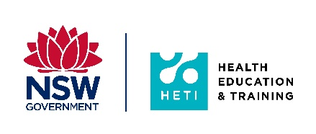
Expression of Interest
Pilot implementation of a revised delivery model for the Surgical Sciences Intensive Course (SSIC)

Please forward your completed Expression of Interest to be a participant in the pilot SSIC directly to HETI at HETI-SSIC@health.nsw.gov.au by Friday 18 June 2021.

Name:

Classification:
(eg: SSN trainee or Trainee working in unaccredited position)
Level:
(eg: PGY4)
SSN Network:
(for SSN trainees only)
Hospital:
(for Trainees working in unaccredited position only)
GSSE Plan:
(please indicate the GSSE sitting you are planning on registering for)

Please provide a statement outlining why you would like to be included in the pilot SSIC?

Please indicate your ability to meet the SSIC Course Requirements | Yes/No
If my EOI is successful, I will register for the SSIC by 30 June 2021
I will undertake and submit the SSIC entry examination
I will review the didactic lectures series between weeks 1 and 11
I will review the anatomy demonstration library between weeks 1 and 11
I will participate in the live virtual Q & A sessions in weeks 3, 6 and 9
I will attend the one-day hands-on anatomy workshop at the Western Sydney University
I will undertake and submit the SSIC exit examination
I will participate in post pilot course evaluation surveys
I will participate in the evaluation of the pilot SSIC

Network Director/Supervisor Approval | Print Name | Signature | Date
I approve the application for EOI and confirm that this trainee will be supported to undertake all the activities required to complete the pilot of the SSIC.

Please attach additional page/s if required

