PROJECT REPORT (PROJECT HC19)

Project title
Maximising Allied Health professional placements in aged care: exploring opportunities for future partnerships within the Newcastle and Coast region

Granting Body
Hunter and Coast Interdisciplinary Clinical Training Network (ICTN), Health Education and Training Institute (HETI).

Researchers
Ms Catherine Johnston
Physiotherapy Lecturer

Mr Clint Newstead
Physiotherapy Clinical Educator

Ms Sarah Walmsley
Project Officer

Dr Lesley MacDonald-Wicks
Senior Lecturer in Nutrition and Dietetics

Associate Professor Pauline Chiarelli
Physiotherapy Program Convenor

Corresponding researcher contact details
Catherine Johnston
School of Health Sciences
The University of Newcastle
Callaghan 2308, NSW
Australia
Phone: 61 2 49217782
Email: cath.johnston@newcastle.edu.au

BACKGROUND

The Australian population is aging with the past decades seeing an increase in those aged over 65 and a rapid rise in those over the age of 85.^{1,2} As people age, healthcare service requirements increase.³ Many older people suffer from chronic illnesses and degenerative conditions.^{4,5} Issues such as falls, poor mobility, musculoskeletal, respiratory and neurological impairments are common in the elderly.^{6,7} In addition, the prevalence of malnutrition is high with those most at risk being the oldest, the frail and those requiring the highest levels of care.^{8,9} Malnutrition is associated with poor health outcomes (including reduced mobility and increased falls risk), decline in overall functional capacity, and increased mortality.^{8,9} Management of these issues, in combination with an emphasis on the promotion of optimal functional ability and general wellbeing¹⁰ requires assessment and intervention from Allied Health professionals such as dietitians and physiotherapists.

The contribution of physiotherapy to aged care is well recognised and the positive effects have been well documented. Physiotherapy intervention has been demonstrated to result in improved mobility, reduction of falls, increases in muscle strength, improved balance and improved functional exercise capacity.^{11,12,13} Similarly the involvement of dietitians in the aged care setting is essential. Dietetic management including nutritional supplementation and the implementation of comprehensive screening, assessment and intervention results in improved clinical outcomes.^{8,14,15,16}
As the population ages an additional demand for services will require a resultant increase in the Allied Health workforce. Currently there is an undersupply of appropriately skilled Allied Health professionals employed, and interested, in aged care.^{3,9,17} To address this, Allied Health professionals need to be exposed to aged care as part of their entry-level training.

Students are expected to enter the professional workforce as competent professionals through acquisition of theoretical knowledge integrated with practical experience. Practical experience in the clinical setting for students undertaking the physiotherapy and nutrition and dietetics programs in the School of Health Sciences (SHS) at The University of Newcastle (UoN) forms an integral part of the entry-level curriculum. Currently entry-level programs in physiotherapy and nutrition and dietetics include academic content relating to aged care within the theoretical components of their respective programmes. However, suitable clinical placements in aged care are extremely limited with very few students in the disciplines of physiotherapy and nutrition and dietetics undertaking placements in this area.

The capacity of aged care facilities in the Hunter and Coast area to participate in clinical education for Allied Health professionals is currently unknown. Information about aged care services, Allied Health staffing and health care professional training and support needs is currently lacking. This paucity of data limits the ability of the physiotherapy and nutrition and dietetics programs in the SHS to utilise these services in the delivery of quality student clinical placements in aged care.

Therefore the aim of this project was to explore the capacity for Allied Health clinical placements in the aged care setting in the Hunter and Coast via:

- Identification, documentation and mapping of clinical placement requirements for physiotherapy and nutrition and dietetics programs at the University of Newcastle

- Identification of aged care facilities in the Hunter and Coast region, Allied Health professional staffing and current Allied Health student clinical placements

- Investigation of the attitudes and training/support needs of aged care managers and Allied Health professionals

METHODS

1. Identification, documentation and mapping of clinical placement requirements for physiotherapy and nutrition and dietetics programs at the University of Newcastle

Information relating to the requirements for clinical placements for the physiotherapy and nutrition and dietetics programmes in the School of Health Sciences at The University of Newcastle was obtained via interviews with the relevant discipline clinical coordinators.

2. Identification of aged care facilities in the Hunter and Coast region, Allied Health professional staffing and current Allied Health student clinical placements

Aged care facilities in the Hunter and Coast areas of NSW were identified using the ‘Aged Care Finder’ on the website www.agedcareaustralia.gov.au

The process of website review is provided in Figure 1.

Geographical areas included in the study were Newcastle (50km radius), Gosford (30 km radius, excluding facilities within the Sydney metropolitan area), Singleton (50 km radius), Tamworth (150 km radius) and Taree (150 km radius). Facilities that offered any level of care were included and special needs were not specified. Within each facility Allied Health professionals were identified. Facilities listing physiotherapy or dietetic services either as ‘staff on-site’ or as ‘scheduled visits by health care practitioners’ were recorded. If a facility was listed as ‘information not yet provided by facility’ the website for the facility was accessed (if available) to determine the level of Allied Health service provided at the facility.

Once the website review was completed, a database of identified facilities was developed. The database included the facility name, location, contact details (including website if available), the level of care provided and number of beds in each level of care. The database was developed to facilitate mapping of potential clinical placements.

Each aged care facility was contacted to determine whether the physiotherapy and/or dietetic service was provided by the facility or contracted to an external provider. Contact details and working hours of Allied Health professionals were obtained if the facility was willing to provide the details.

For each site identified as a result of the website review, the potential for student clinical placements was determined.

Once the mapping exercise was complete the information was transferred into a proforma in oder to be used for future planning of placements. The proforma is presented in Appendix 1.

3. Investigation of the attitudes and training/support needs of aged care managers and Allied Health professionals

The Human Research Ethics Committee of The University of Newcastle granted ethical approval for this section of the project. Approval number: H-2013-0036

Allied Health professionals and managers of aged care facilities identified in section 2 were invited to participate in a short written survey. Ninety-three managers of aged care facilities and 95 Allied Health professionals (physiotherapists and dieticians) identified in section 2 were invited to participate in the written postal survey (Appendices 2 and 3).

The survey included questions about current level of student activity, scope for future clinical placements together with questions about attitudes towards student placements: potential advantages, disadvantages and perceived support needs.

FIGURE 1: Website review process
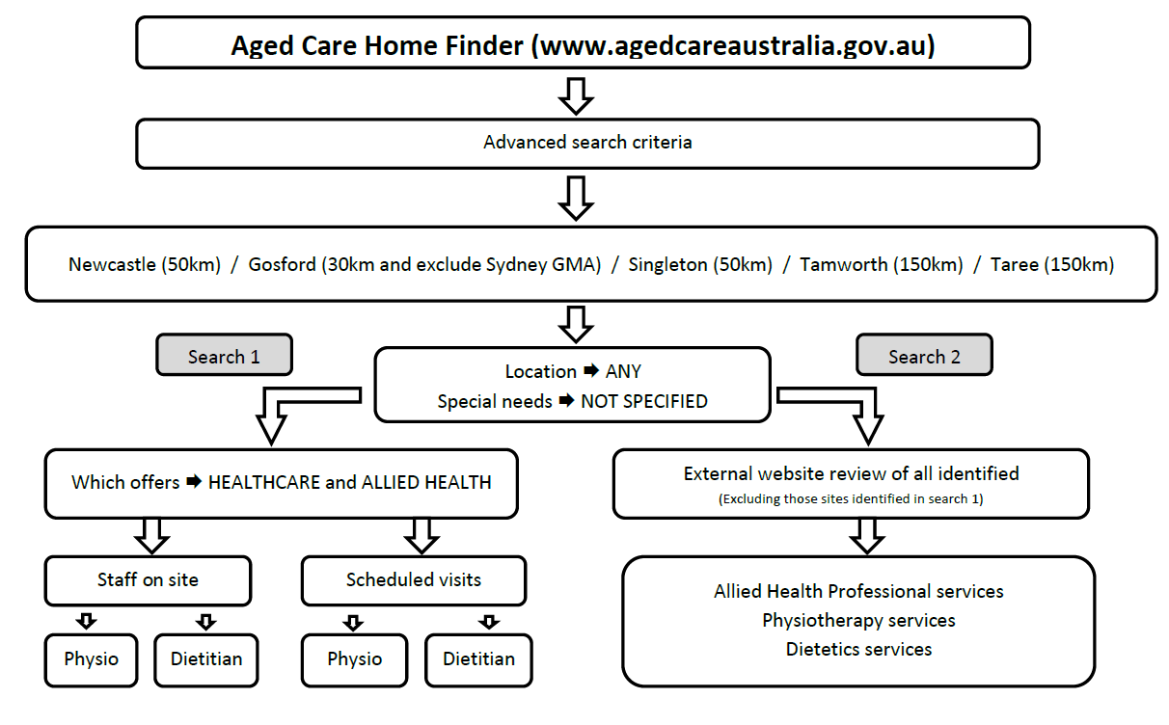
RESULTS

1. Identification, documentation and mapping of clinical placement requirements for physiotherapy and nutrition and dietetics programs at the University of Newcastle

Student supervision
In both the physiotherapy and nutrition and dietetics disciplines, student supervision on clinical placements is provided by clinicians employed by the facility. These clinicians usually also have clinical and administrative responsibilities in addition to supervising students. Supervision is not provided by University staff members and there is no remuneration for student supervision.

Physiotherapy
Within the physiotherapy programme, students are introduced to learning within clinical settings early in the programme. In year 1 (semester 1), students undertake preparation for clinical practice followed by regular half-day placements for 2 semesters. Full-time block placements occur from year 2 second semester. The first four week block placement in year 2, is where students integrate basic theoretical and practical skills in a clinical setting. Clinical placements in third and fourth year build upon the foundation of the experiences gained in first and second year and are five week block placements across a variety of settings. To ensure comprehensive and broad experience across the programme, all students undertake placements including acute/cardiopulmonary; rehabilitation/neurology; musculoskeletal; community practice and integrated general. Within this framework there is the capacity to incorporate experience in an aged care setting into the programme.

Nutrition and Dietetics
The nutrition and dietetics programme has a clinical placement programme that aims to ensure entry-level students are equipped with the practical skills required to enter the professional workforce. The clinical placement programme provides students experience within the three domains of practice and specialities including clinical, or one to one patient interaction within a health care setting including aged care; community, public health or nutrition groups and food service where the focus is on the delivery of food to an institution or facility including aged care facilities.

Four week block placements commence in year 2 when groups of students gain practical experience in community or public health settings. Year three of the programme is when students are involved in the clinical aspect of their role which is largely observational. The final year of the programme includes practice in a variety of clinical settings including a 10 week clinical placement, a five week community placement and a three week food service placement.

2. Identification of aged care facilities in the Hunter and Coast region, Allied Health professional staffing and current Allied Health student clinical placements

Data collected from the aged care website and websites was recorded. The results of the initial website review are presented in Figure 2

An example of the how the information gained from the mapping exercise was collated is presented in Appendix 4. Aged care facilities with the potential to provide clinical placements with adequate levels of supervision were identified.

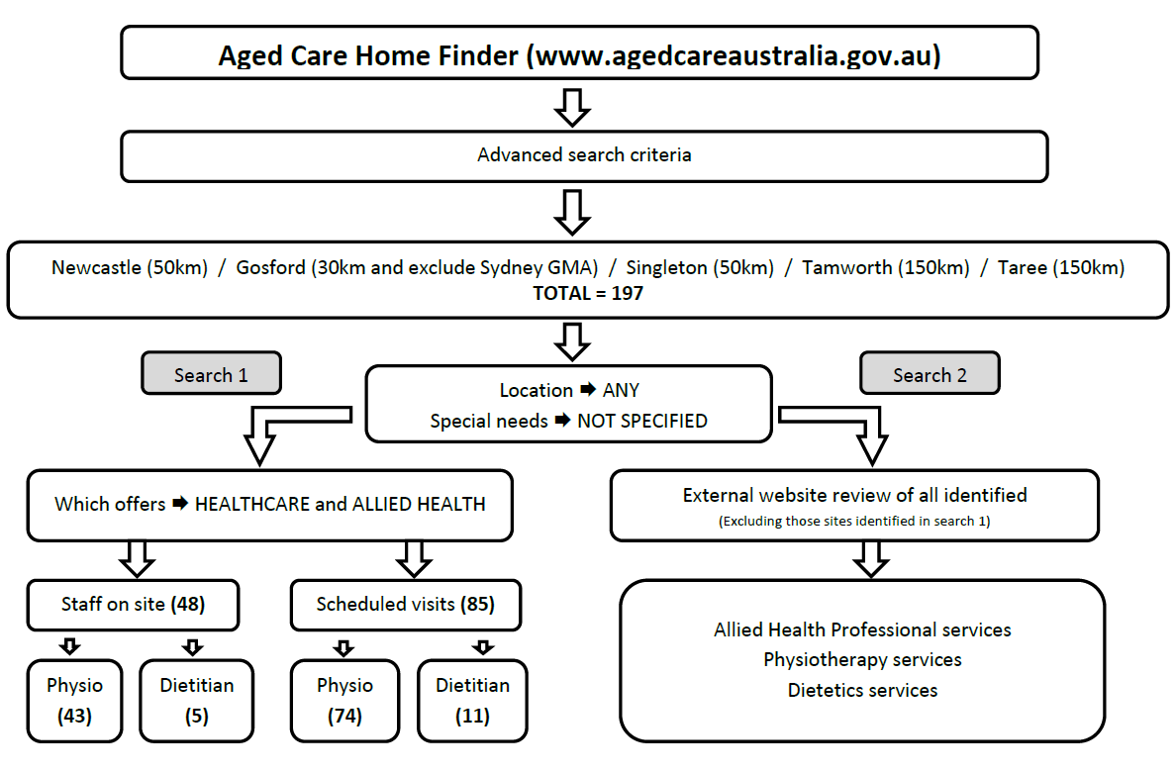
FIGURE 2

3. Investigation of the attitudes and training/support needs of aged care managers and Allied Health professionals – survey results

Participant characteristics
Thirty-seven (40%) aged care facility managers, 25 (32%) physiotherapists and (6%) dieticians returned completed surveys. The characteristics of the participating Allied Health Professionals are detailed in Table 1 and the participant characteristics of the aged care facility managers are detailed in Table 2. The mean number of years of experience of managers in aged care facilities was 13 years (SD 8.8, Range = 2 – 30).

Table 1. Characteristics of Allied Health participants (n=26)

Characteristic | n (%)
Gender
Female | 16 (62)
Male | 10 (38)
Professional background
Nutrition and dietetics | 1 (4)
Physiotherapy | 25 (96)
Years since qualification
< 1 year | 1 (4)
1-4 years | 3 (12)
5-10 years | 3 (12)
11-15 years | 2 (8)
>15 years | 17 (64)

Table 2. Characteristics of aged care facility managers (n=37)

Characteristic | n (%)
Gender
Female | 32 (87)
Male | 4 (11)
Did not specify | 1 (2)
Professional background
Health | 31 (84)
Other* | 6 (16)

Current student placements
Seventy percent of managers reported that students currently attended their facility. The disciplines involved in clinical placements, as reported by the managers of each facility, is shown in Figure 3.

Figure 3. Current placements in aged care facilities by discipline

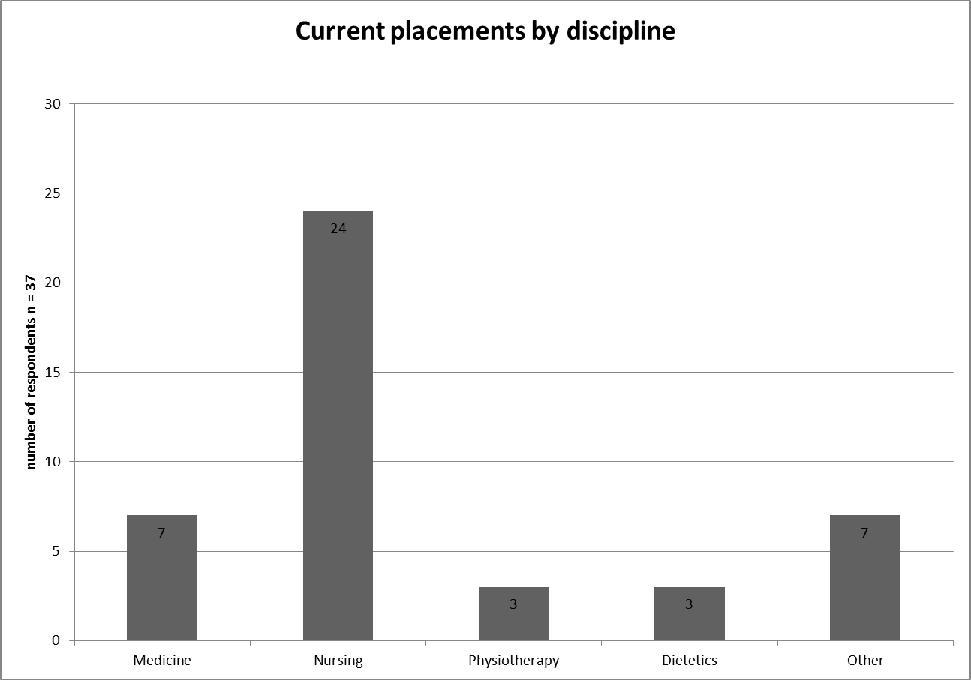

Student supervision
Allied Health professionals current and past involvement in student supervision is presented in Figure 4

Those Allied Health professionals who were not currently supervising students were asked the reasons for this. The most commonly cited reasons were that they had not been approached regarding student placements, there was limited time available to provide supervision and that services provided were on a needs basis only.

Figure 4. Current and previous Allied Health Professionals supervision of students

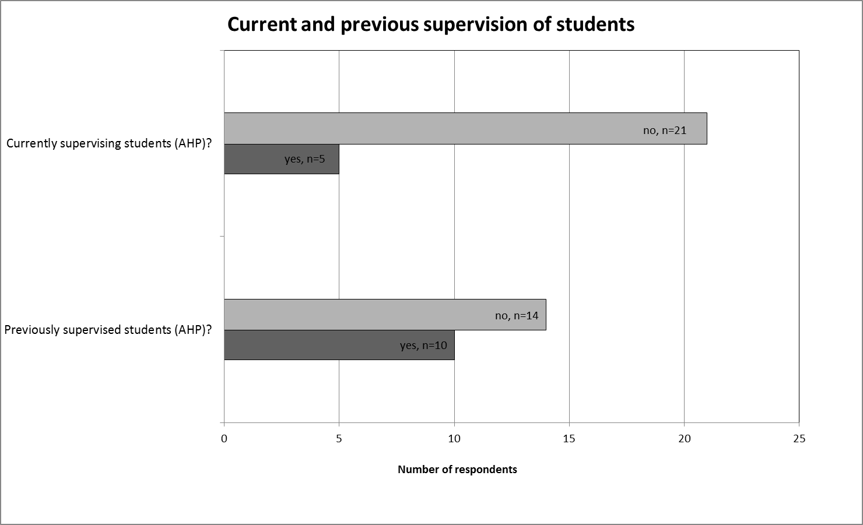

Perception of advantages, disadvantages and barriers to student placements
The opinions of aged care facility managers and Allied Health professionals regarding the advantages, disadvantages, barriers and scope for clinical placements is shown in Figure 5.

There was no significant difference between managers and Allied Health professionals in reporting whether they thought there were advantages (p = 1.0), or barriers (p = 0.43) to placements in aged care. More Allied Health professionals indicated there were disadvantages, however this was not statistically significant (p = 0.11). There was a significant difference (p = 0.005) in the response between managers and Allied Health professionals in their opinion about the scope of their facility to provide Allied Health professional student placements.

Figure 5. Managers and Allied Health professionals opinions regarding student placements in aged care

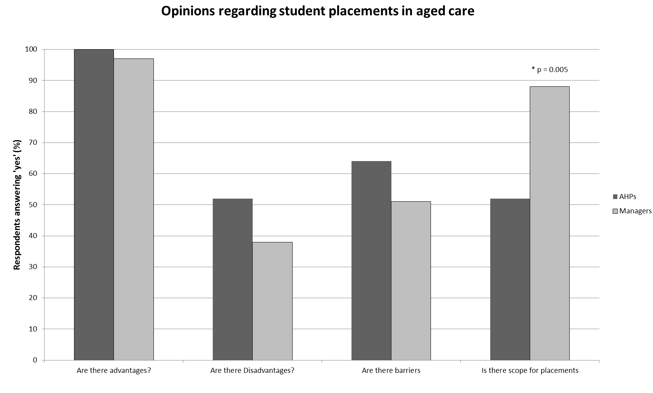

Comments regarding advantages, disadvantages and barriers to student placements
Managers and Allied Health professionals were invited to provide written comments on advantages, disadvantages, barriers to clinical placements within their aged care facility. Comments and quotes illustrating themes are presented in Table 3

Support and training
Managers and Allied Health professionals were invited to provide written comments on the support and training that they required in order to facilitate the delivery of student clinical placements. Comments and quotes illustrating themes are presented in Table 4

TABLE 3: Advantages, disadvantages and barriers to student clinical placements in aged care: Managers and Allied Health professional comments

Table 3.

 | Managers | Allied Health professionals
Advantages | Generally the comments by managers indicated that clinical placement of Allied Health professionals would enable students to appreciate the needs of the older person and the aged care setting as well as give other staff learning opportunities of Allied Health practices and build teamwork.  “Students get a first-hand experience dealing with the elderly and their challenges eg. dementia behaviours”  “Learning how to relate to the elderly and gain their trust and co-operation”  “Opportunities to engage other staff in learning”  “Advantageous for both residents and students – residents are assisted with services/students receive education about the ageing process”  Ageing population – many Allied Health professionals will be finding their employment is aged related services” | The advantages identified by the Allied Health professionals included the benefit of exposure of students to aged care. They also suggested that student placements in aged care may have the potential to increase the number of Allied Health professionals considering employment in aged care.  The ability to develop skills including communication, manual handling, provision of mobility aids, the ability to deal with multiple pathologies in one person and pain management were also highlighted.  “Aged care is a potential work setting post graduation”  “Great manual handling experience; great patient/staff communication experience; good experience with comprising the ideal and the practical”  “Growing need – ageing population increasing occupancy in aged care”  “It is a great introduction to general physiotherapy, communication and professional behaviour – so perfect for early placements”  “To provide students with some insight into the importance of physiotherapy for the aged and in the aged care setting”
Disadvantages | Lack of adequate supervision, time and financial support were identified by managers as the major disadvantages of Allied Health professional students in aged care.  “Aged care has time constraints, resourcing constraints”  “Limited time, facility and financial resources to co-ordinate interdisciplinary student placements”  “Currently only part-time Allied Health professionals so may not be enough hours”  “Limited support”  “Lack of qualified supervisors” | The disadvantages identified by the Allied Health rspondents included dealing with aged persons may be confronting for some students and also dealing with death and dying may present difficulties for some students. Also identified was that it may influence students to dislike aged care as a future workplace.  “Has the potential to create a dislike for aged care due to the slow rate of improvement (ie. over a 4 week placement, students may not actually see the benefit of physiotherapy intervention)”  “It’s not sexy”
Barriers | The barriers identified were similar to the disadvantages listed above.  “Funding for an educator would be required at a facility like mine”  “Limited time, financial resources, supervision, peaks and troughs in student placements”  “Requirement to ensure the students have a facilitator on site or access to a facilitator” | The barriers identified by the Allied Health respondents were generally concerned with lack of appropriate supervision available; limited time available as most Allied Health professionals only visited aged care facilities on a part-time basis; a lack of resources including financial resources was also identified.  “Lack of continuous professional supervision, frequently staffed by part-time professionals”  “Finding full-time physiotherapy provisioned services”  “Qualified supervision not always available”
General comments | The general comments provided by managers were positive with many indicating they would be willing to participate in student clinical placements.  “This would be very advantageous for both residents/students as well as other staff”  “Win win!”  “Great idea. Gives the industry a chance to attract younger/more staff. Promotes a learning environment” | General comments from Allied Health professionals were essentially positive.  “I believe it is important for students to have exposure to the aged care setting so as to encourage them to work in this area of great need in the future”  “Bring it on”

Table 4: Perceived support and training needs of Managers and Allied Health professionals in aged care.

 | Managers | Allied Health Professionals
Support and training needs | Managers of aged care facilities commented that they would require support and training from the University if they were able to have student clinical placements.  In particular the provision of adequate supervision was highlighted.  Some managers identified financial implications of a potential increased workload.  “Some extra hours for current Allied Health professionals to spend time with students”  “Support to students through the University”  “Clinical supervisor; education for staff regarding the benefits of student placement”  “Need clinical facilitator to oversee placement”  “Funding to cover extra support time for physio to monitor (the students)” | The need for a clinical supervisor/mentor/facilitator was highlighted by Allied Health professionals. Respondents commented on the need to be updated on current teaching practices and skills taught to students. Training of Allied Health professionals currently in aged care to fulfill the University requirements was a concern raised by a number of respondents.  “More details in student’s competencies, their capabilities, students expectations etc”  “Support from their educators”  “Having a supervisor”  “Training for supervisors to ensure appropriate knowledge and skills consistent with what students are learning and the level they should be working at”

DISCUSSION

The purpose of this project was to investigate the potential to increase placement capacity in the aged care setting in the Hunter and Coast area. The project resulted in a successful mapping of local aged care facilities. Facilities with the potential to deliver placements for physiotherapy and/or nutrition and dietetics students were identified and documented. The survey of Allied Health professionals and Managers, undertaken as part of the project, resulted in a greater understanding of attitudes toward student placements and of training and support needs. The integration of information from both aspects of the project will facilitate the development of new partnerships and future placement opportunities.

The review of the Government website the Aged Care Finder was useful as an initial process. However once commenced, it was found that the information listed with the website was often incomplete and, on further investigation, inaccurate. The initial Aged Care Finder review was therefore supplemented by a more general public internet review of the listed aged care facilities. It was evident, through these review processes, that there is a shortage of Allied Health professional staffing in aged care. Many of the listed sites had little to no service provision by Allied Health. In particular, dietetic services in this setting were almost non-existent. In addition, many sites had Allied Health coverage that was split between multiple facilities. These issues are major barriers to growing clinical placement capacity in this setting. Both physiotherapy and nutrition and dietetic students require discipline specific supervision to enable performance assessment against professional standards.

Despite the general lack of Allied Health professional staffing, some sites were identified which had the potential to provide students with placement experiences. As a result of this project up to 17 sites where placement possibilities could be further explored and developed were identified. The next step in the process of establishing viable clinical placements is to make contact with the various sites identified to further investigate opportunities and determine the support and resources that may be required. Consideration will also need to be given to issues such as ensuring adequate case loads and opportunities to demonstrate competence and also to students having multiple educators or placements being run across multiple sites.

The survey of aged care Managers and Allied Health professionals was undertaken to support the mapping exercise. The survey aimed to canvas attitudes and opinions regarding student placements and to gauge support and training needs. To our knowledge this is the first survey of its kind and, despite the small response rates will be an excellent basis for further research and will be invaluable in enabling the development of placement capacity in aged care.

The results of the survey of aged care facilities in the Hunter and Coast area identified that the majority of Allied Health professional currently employed in aged care have been qualified for greater than 15 years (64%) and generally only work in a part-time capacity. Managers of aged care facilities were generally from a health professional background. As well as most Allied Health professionals being employed on a part-time basis many are contracted to the facility rather than being employed directly by the facility. Contractors were either local private physiotherapy or dietetic practices or in some instances Allied Health staff were employed by a company specialising in the provision of Allied Health services specifically to aged care facilities. It was also identified that a number of physiotherapists provided services to more than one aged care facility potentially enabling the combination of facilities to create a single clinical placement.

Both Manager and Allied Health professional attitudes to student clinical placements were very positive. Most agreed that there were advantages to placements in aged care. They saw placements in aged care as important and essential in exposing students to a potential future work environment The ability for students to learn a variety of relevant clinical skills as well as deal with people with multiple pathologies was also highlighted. Managers and Allied Health professionals were also realistic in identifying challenges to placements in aged care. Reports of disadvantages and barriers to the introduction of student clinical placements were generally concerned with the lack of available supervision or mentoring available for students as well as provision of suitable support funding. Further, the part-time nature of employment of most Allied Health professionals may make full-time placements problematic.

Interestingly the Allied Health professionals were more likely to indicate disadvantages and perceived less scope/feasibility for placements than the Managers. This discrepancy may be as a result of the Allied Health professionals’ clearer understanding of the requirements for student clinical placements including supervision and assessment. It is possible that facility managers, inexperienced in Allied Health clinical education, are unaware of the necessity for students to have full-time professional supervision and formal assessment by facility staff rather than ‘buddying’ a facility staff member and/or being supervised by a University provided staff member. They may also be unaware that there is currently no funding support provided for the supervision of Allied Health students on clinical placement.

Given the above issues, it is not surprising then that very few of the survey respondents indicated that they were currently participating in student supervision. Although the majority of physiotherapists employed in the aged care setting were experienced clinicians, they lacked experience in clinical supervision and appeared to lack confidence that their skills would be adequate to be able to effectively participate in clinical education. Many indicated that there was scope for placements in their facilities with several indicating that the reason they did not participate in placements was that they had not been approached. The need for further education and training was highlighted by survey respondents. This is an area that the Disciplines of physiotherapy and nutrition and dietetics at the UoN can potentially address through the development and delivery of specific supervisor workshops (and associated resources) for Allied Health professionals working in aged care.

In conclusion, this project has successfully mapped aged care facilities in the Hunter and Coast areas, has identified sites with potential for involvement in clinical placements and has completed a preliminary investigation of the attitudes and opinions of Managers and Allied Health professionals in aged care. Further work will now be undertaken to build on the project initial findings and to develop partnerships which will enable increase capacity for clinical placements in the aged care setting.

REFERENCES

1. Richmond R.L.(2008) The changing face of the Australian population : growth in centenarians. Med J Aust: 188 (12): 720-723.

2. Australian Bureau of Statistics (2011). "Population by age and sex, Australian states and territories." from http://www.abs.gov.au/ausstats/abs@.nsf/Previousproducts/3101.0Feature%20Article1Jun%202011?opendocument&tabname=Summary&prodno=3101.0&issue=Jun%202011&num=&view=

3. National Health Workforce Taskforce . “Health workforce in Australia and factors for current shortages 2009.” From: http://www.ahwo.gov.au/documents/NHWT/The%20health%20workforce%20in%20Australia%20and%20factors%20influencing%20current%20shortages.pdf

4. Rizza A, Kaplan V, Senn O, Roseman T, Bhend H, Tandjung R (2012) Age and gender related prevalence of multimorbidity in primary care: the swiss fire project. BMC Family Practice 13:113

5. Gilbert AL, Caughey GE, Vitry AI, Clark A (2011) Ageing well: improving the management of patients with multiple chronic health problems. Australasian Journal on Ageing 30, Supplement 2: 32-37.

6. Grancher U, Muehlbauer T, Gollhofer A, Kressig RW, Zahner L (2011) An intergenerational approach in the promotion of balance and strength for fall prevention- a mini review. Gerontology 57: 304-315.

7. Australian Bureau of Statistics. National Health Survey: Summary of Results 2004-2005. Cat No 4364.0. Commonwealth of Australia, Canberra: ABS, 2006.

8. Banks M, Ash S, Bauer J, Gaskill D.(2007) Prevalence of malnutrition in adults in Queensland public hospitals and residential aged care facilities. Nutrition and Dietetics; 64: 172-178

9. Gaskill D, Black LJ, Hassall S et al (2008). Malnutrition prevalence and nutrition issues in residential aged care facilities. Australasian Journal on Ageing 27: 189-194.

10. Partridge C, Johnston M, Morris L (1996) Disability and health: perceptions of a sample of elderly people Physiotherapy Research International 1 (1): 17-29.

11. Gusi N, Adsuar JC, Corzo H, del Pozo-Cruz B, Olivares PR, Parraca JA (2012) Balance training reduces the fear of falling and improves dynamic balance and isometric strength in institutionalised older people: a randomised trial. Journal of Physiotherapy 58: 97-104

12. Hasselgren L, Olsson L, Nyberg L (2011) Is leg muscle strength correlated with functional balance and mobility among inpatients in geriatric rehabilitation? Archives of Gerontology and Geriatrics 52: e220-e225

13. Howe TE, Rochester L, Neil F, Skelton DA, Ballinger C (2011) Exercise for improving balance in older people. Cochrane Database of Systematic Reviews: CD004963.pub3

14. Gaskill D, Isenring EA, Black LJ et al (2009). Maintaining nutrition in aged care residents with a train-the-trainer intervention and nutrition coordinator. Journal of Health Nutrition and Aging 13, 913-917.

15. Greiger JA, Nowson CA, Jarman HF, Malon R and Ackland LM (2009). Multivitamin supplementation improves nutritional status and bone quality in aged care residents. European Journal of Clinical Nutrition 63:558-565

16. Milne AC, Potter J, Vivanti A, Avenell A. Protein and energy supplementation in elderly people at risk from malnutrition. Cochrane Database of Systematic Reviews 2009, Issue 2. Art. No.: CD003288. DOI: 10.1002/14651858.CD003288.pub3.

17. Hobbs C, Dean C, Higgs J, Adamson B. (2006) Physiotherapy students’ attitudes towards and knowledge of older people. Australian Journal of Physiotherapy 52: 115-119

APPENDICES

Appendix 1: Mapping Proforma
Site name
Location
Physiotherapy service description | Capacity for Placements
Dietetics service description | Capacity for Placements
General comments

Appendix 2: Allied Health professional survey

Catherine Johnston (Chief Investigator)
Clint Newstead
Sarah Walmsley
Lesley MacDonald –Wicks
Pauline Chiarelli

School of Health Sciences
The University of Newcastle
Callaghan, 2308 NSW
Ph 02 4921 7782, Fax 02 4921 7479
cath.johnston@newcastle.edu.au

Allied Health professional placements in aged care: capacity, attitudes and support needs.

Allied Health Professional Survey
Document Version 1; dated 4/2/2013

Section 1: Information about you

1. What is your gender?
female male

2. What is your profession? (tick one)
Physiotherapist Dietitian, please indicate your role (tick one or both as applicable):
Food Services Clinical

3. How long ago did you complete your entry level professional qualification? (tick one)
Less than 1 year
Between 1 and 4 years
Between 5 and 10 years
Between 11 and 15 years
Greater than 15 years

Section 2: Student supervision
The questions in the following section relate to supervision of either physiotherapy or dietetics students. Please answer with respect to your professional background.

4. Do you supervise students in your current position? (tick one)
No Go to Q6 Yes

5. If yes, what type of placements have you supervised? (tick any that apply)
Full time block placements
Part time/sessional
6. If you stated you do not supervise students at present, what are some of the reasons that you do not currently supervise students?

7. If you stated you do not supervise students at present, do you feel your aged care facility(s) has the scope to provide Allied Health Professional student placements? (tick one)
No Yes

8. Have you ever supervised students in previous positions? (tick one)
No Yes

Section 3: Student placements in aged care

9. Do you think there are advantages for Allied Health Professional students in undertaking placements in the aged care setting? (tick one)
No (go to Q10) Yes

If yes please briefly describe the advantages

10. Do you think there are disadvantages for entry level Allied Health professional students in undertaking placements in the aged care setting? (tick one)
No (go to Q11) Yes

If yes please briefly describe the disadvantages.

11. Do you think there are any barriers to entry level Allied Health professional students in undertaking placements in the aged care setting? (tick one)
No (go to Q12) Yes

If yes please briefly describe the barriers

Section 4: Training and support needs

12 What additional support/training/resources do you think would be useful to facilitate Allied Health Professional student placements in the aged care setting?

Support

Training

Resources

Section 5: General comments
13. Do you have any further comments about entry level Allied Health professional student placements in the aged care setting?

Section 6: Ongoing Contact

14. Are you happy to have further contact with the School of Health Sciences and Nutrition Dietetics or Physiotherapy academic staff regarding student placements?
No Yes

If yes, please indicate your preferred mode of contact and provide details in the space below:

Thank you very much for your time and your participation in this survey
Appendix 3: Managers survey

Catherine Johnston (Chief Investigator)
Clint Newstead
Sarah Walmsley
Lesley MacDonald –Wicks
Pauline Chiarelli

School of Health Sciences
The University of Newcastle
Callaghan, 2308 NSW
Ph 02 4921 7782, Fax 02 4921 7479
cath.johnston@newcastle.edu.au

Allied Health professional placements in aged care: capacity, attitudes and support needs.

Aged Care Manager Survey
Document Version 2; dated 15/3/2013

Section 1: Information about you
1. Gender female male

2. Professional background (describe – health / business / managerial / other)
Health professional Other, please specify:____________________________

3. Years in aged care management positions (number of years): _____________________________

Section 2: Student placements in aged care settings
4. Do you currently have entry level health professional students in your facility? (tick one)
No Yes

5. If yes what profession(s)?
Medicine Nursing Physiotherapy Dietetics
Other Allied Health, please specify:__________________________________________________

6. If no, what are some of the reasons you do not have students in your facility?

7. Do you think there are advantages for Allied Health Professional students in undertaking placements in the aged care setting? (tick one) No (go to Q11) Yes

Please briefly describe the advantages

8. Do you think there are disadvantages for Allied Health Professional students in undertaking placements in the aged care setting? (tick one) No Yes

Please briefly describe the disadvantages

9. Do you think there are any barriers to entry level Allied Health professional students in undertaking placements in the aged care setting? (tick one) No Yes

Please briefly describe the barriers (may need to prompt to cover both specific issues relating to their facility and more general issues eg funding)

Section 4: Training and support needs
10. Do you feel your facility has the scope to provide Allied Health Professional student placements? (tick one) No Yes

11. Please outline reasons for your answer

12. What additional support/training/resources do you think would be useful to facilitate entry level Allied Health professional student placements in your aged care facility?

Section 5: General comments
13. Do you have any further comments about level Allied Health Professional student placements in the aged care setting?

Section 6: Ongoing Contact
14. Are you happy to have further contact with the School of Health Sciences and Nutrition Dietetics or Physiotherapy academic staff regarding student placements?
No Yes

If yes, please indicate your preferred mode of contact and provide details in the space below:

Thank you very much for your time and your participation in this survey

Appendix 4: Example of results of mapping exercise

Site name
Presbyterian Aged Care - Westcott
Location
Stockton
Physiotherapy service description | Capacity for Placements
Contracted by Agewell Physiotherapy  2 days per week  Role is essentially consultant to advise re programmes/pain management for PTA’s to manage  Physio Kate Vanderweyde 043800653 | ? Possible to combine facilities to make a placement  Kate also works at St John’s Villa and Whiddon Group Belmont 1 day/week each
Dietetics service description | Capacity for Placements
Nil identified on website | Nil
General comments

